23.15: points from high potential to low potential, so 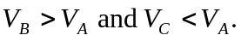
The force on a positive test charge is east, so no work is done on it by the electric force when it moves due south (the force and displacement are perpendicular); 